

G2 EE

Cycle Counting

QAD EE Training Document

Cycle Counting

Table of Contents
Objective 3
Updating the ABC Class 3
Item ABC Code Metrics 3
Cycle Count Worksheet Print 3.13.1 3
Cycle Count Results Entry (Initial) 3.13.2 5
Transaction by Item Browse (3.21.2) 8
Setting Item Tolerance % 10

Objective
Purpose of this document is to explain the cycle counting process
Refer to the current BOS document on Cycle Counting for more details of the current standards and procedures:
Inventory Reconciliation Procedure
Cycle Count Worksheet / Checklist
Cycle Count must be performed on all locations with inventory. The aim of this is to ensure the highest possible reliability of stock quantities across the plant. In AS there are many locations as each shelf is a system location. CIM load is a good solution to quickly perform cycle count across all locations. Initial bookings should be used (no change in inventory if out of tolerance), as movements in the system between the time of counting and uploading the CIM load could result in large and incorrect changes in stock quantities. See CIM Load instruction for more details on carrying out CIM Loads.

Updating the ABC Class

It is not advised to use the automated update of the ABC classes in QAD (Item ABC Status Report/Update) because these do not reflect all Adient classes (A,B,C,D,E) and the results are not reliably correct.
Calculation and classification should take place in Excel, based on the BOS standard values and a CIM load imported into Item Inventory Data Maintenance 1.4.5 to update the system.
See separate instruction for QAD CIM-Load.
See the corresponding BOS documents to see the current standards for ABC class: ABCDE Definition and Classification Standard.

Item ABC Code Metrics

A Metric for ABC class and parts without and class should be available in QAD. At the time of writing this feature was not yet available.

Cycle Count Worksheet Print 3.13.1
This program can be used to list parts due for counting or create a print out where counts can be entered by hand. There are various parameters which can be used to choose which parts are to be counted.
Item Number: Item which is to be counted
Location: Location of items to be counted
Last Count: Items that were cycle counted last time within this period
ABC Class: Items of a specific ABC class
Number of Items: You can limit the number of items to be counted. Default value is “999999999”, if left the following two fields will have no effect.
A, B, C, Other: If the number of items has been limited then this setting will result in the required percentages of each class being included in the parts to be counted
Randomize Selection: If selected then the selection does not use results of earlier counts. It is as likely to select an item that was counted yesterday as an item that has never been counted.
Sort by Item or Site: Item specifies that items are to be reviewed and selected in item code sequence. Site specifies items are to be reviewed and selected in sequence by site and then item code. The default setting is item.
Past Due Only: Indicates if only items due to be counted are to be included in the report.
Print Quantity OH: Adient policy states that system quantities should not be visible to Cycle Counters. This should therefore remain set to “no”.
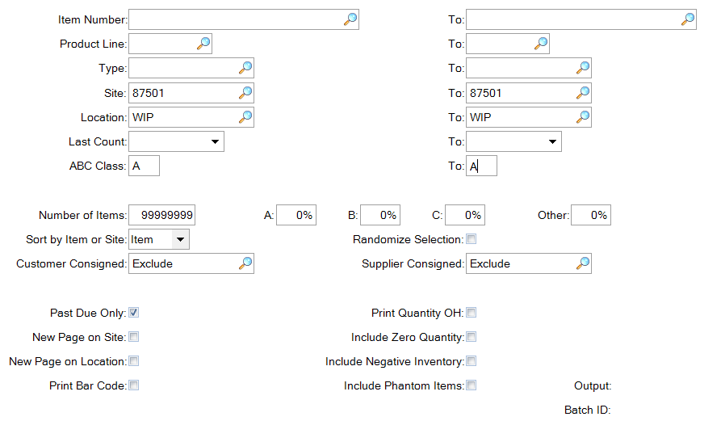

The system will then produce a report showing the parts to be counted.
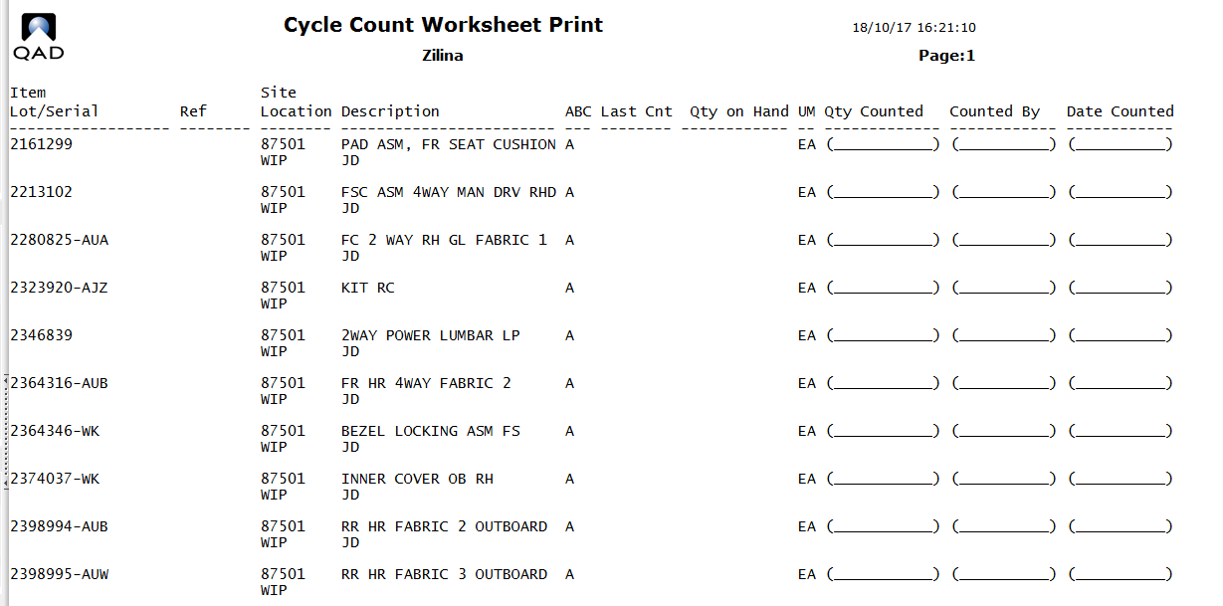

To export to Excel:
By entering an output name when creating the report it will then be available in the plant’s home directory to be transferred using the local file transfer tool (typically WIN SCP) and then opened in Excel.

Cycle Count Results Entry (Initial) 3.13.2

Entering the results from a Cycle Count, be it an initial count or recount, is done under “Cycle Count Results Entry (initial)” (3.13.2)
You can enter the results as an “Initial” or a “Recount”. The default is Initial.
If the cycle count type is Initial, the qty on hand is compared to the count quantity.
If the difference is WITHIN the allowed error tolerance, the item quantity on hand IS UPDATED to the count amount.
If the difference is OUTSIDE the allowed error tolerance then the quantity on hand is not updated and the message will be displayed “Quantity on hand will not be changed.”
The Transaction History maintains a complete audit trail of all cycle count transactions.
They are separated by type CYC-CNT, CYC-ERR, & CYC-RCNT and list the user ID who entered the count.

Cycle Count Entry:
Cycle Count Type: State whether this is an Initial or a Recount
Item Number: Item counted
Site: This is the SITE where you counted the part.
Location: This is the LOCATION in which you counted the part.
By deleting the automatically shown standard location and clicking the magnifying glass next to location field the system will show all locations for this part with the corresponding quantities
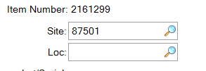
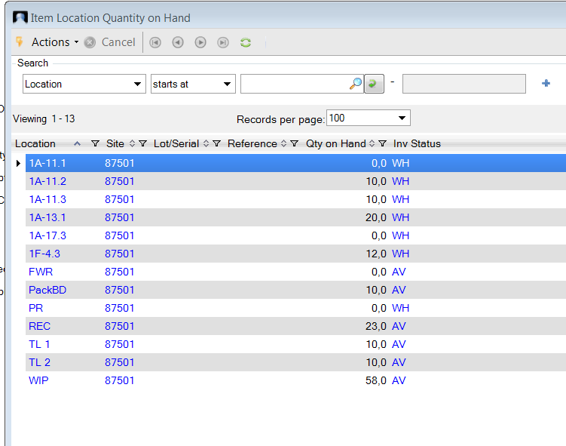
The required location for the CC booking can be selected from this list.

The tolerance method is QOH, and it displays the tolerance %.
The date of the last cycle count is as well displayed together with the current qty on hand on the selected location.

Quantity Counted: The numbers of parts counted in the location.
The QOH variance displayed as a %.
Annual usage variance displayed as a %.
Amount variance is displayed in your base currency.

Remarks: You can add in some text remarks. (Optional field)
Effective: When this cycle count transaction is effective.
Cr: General Ledger account credited by this transaction. (Check with Finance)
Amount: Total value in base currency for this cycle count.
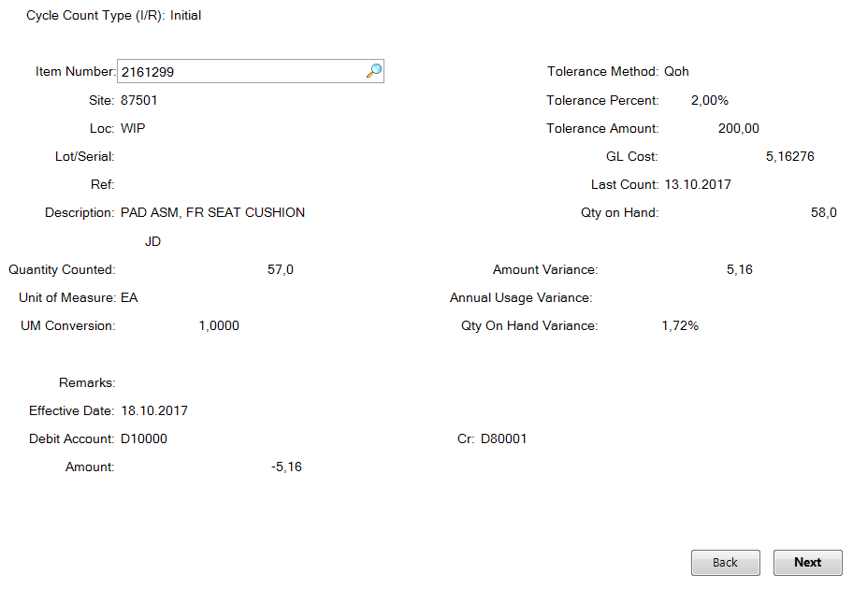
Once the data is entered, and you press next, you will be asked to confirm the information.
Selecting “Yes” confirms this cycle count.
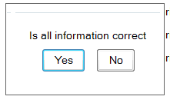

A Cycle recount is performed in the same program, Recount is simply selected at the top of the screen. If the cycle count type is Recount, the quantity on hand is updated to the count amount even if it is out of tolerance.
Notice that when Recount is selected that the ERROR message “Quantity on hand will not be changed.” is no longer displayed. The system is now only warning you that the count is out of tolerance.

Transaction by Item Browse (3.21.2)
Viewing booked cycle count transactions
Performing a cycle count entry will generate a transaction, and all transactions can be traced. Use the option “Transactions by Item Browse” 3.21.2. To see all Cycle Count transactions search for transaction type contains cyc* and the three possibilities (CYC-ERR, CYC-CNT and CYC-RCNT) will be displayed.
Add further search criteria by clicking on the blue plus.
Here all three different types of cycle count transactions are visible:
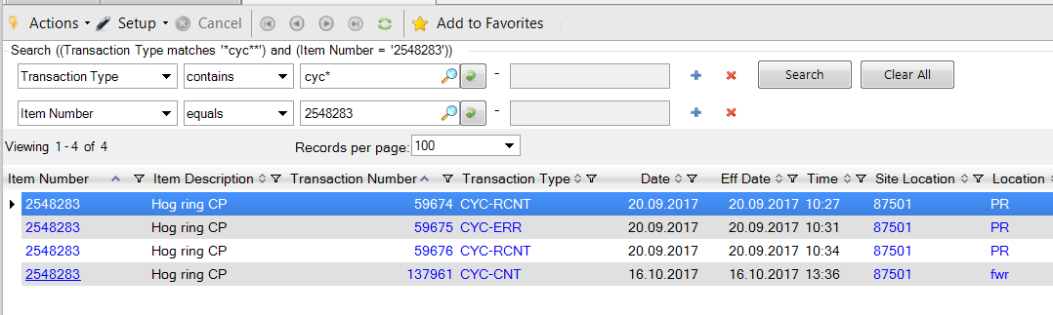
CYC-RCNT: Entry using Recount function, stock quantity is adjusted regardless of tolerance
CYC-ERR: Entry using Initial function, counted quantity was outside of tolerance so stock quantity was not adjusted
CYC-CNT Entry using Initial function, counted quantity was within tolerance so stock quantity was adjusted
Be sure that the desired outcome has been obtained – following a CYC-ERR transaction the system will continue to order parts based on the incorrect stock quantities.

By selecting a specific transaction it is possible to view the precise details of the transaction in 3.21.1

Here for CYC-CNT:

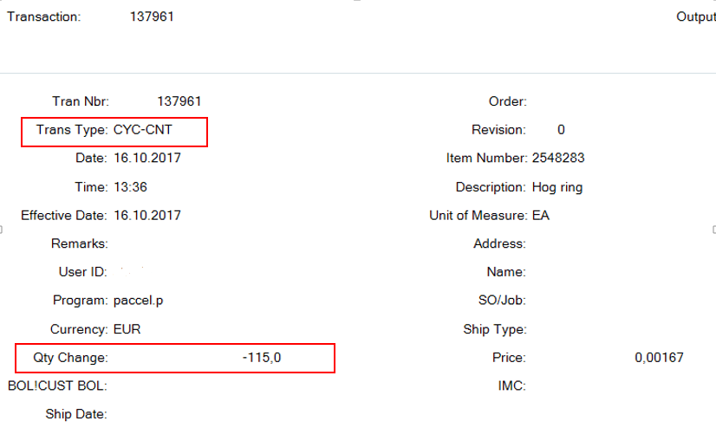
And for CYC-ERR
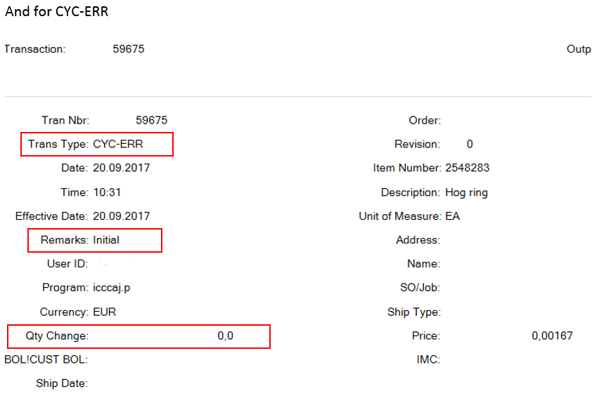

Setting Item Tolerance %

Item tolerances are set by the central team based on the Adient Standard.
At time of writing:
